**Dense Rank**

select vehicle_type_desc

, vehicle_desc

, sum(fct_quantity)

, sum(fct_amount)

, dense_rank() OVER (PARTITION BY vehicle_type_desc order by sum(fct_amount) desc) "Rank"

from delivery

where extract (year from event_dt) = 2013

group by vehicle_type_desc, vehicle_desc

order by vehicle_type_desc, sum(fct_amount) desc

;

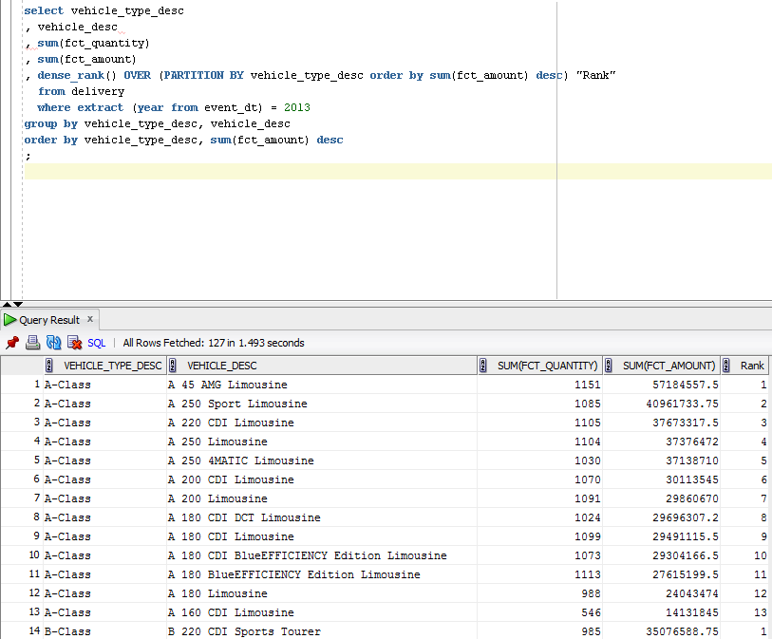

**Rank**

select vehicle_type_desc

, vehicle_desc

, sum(fct_quantity)

, rank() OVER (PARTITION BY vehicle_type_desc order by sum(fct_quantity) desc) "Rank"

from delivery

where extract (year from event_dt) = 2013 and vehicle_type_desc = 'CLS-Class'

group by vehicle_type_desc, vehicle_desc

order by vehicle_type_desc, sum(fct_quantity) desc

;

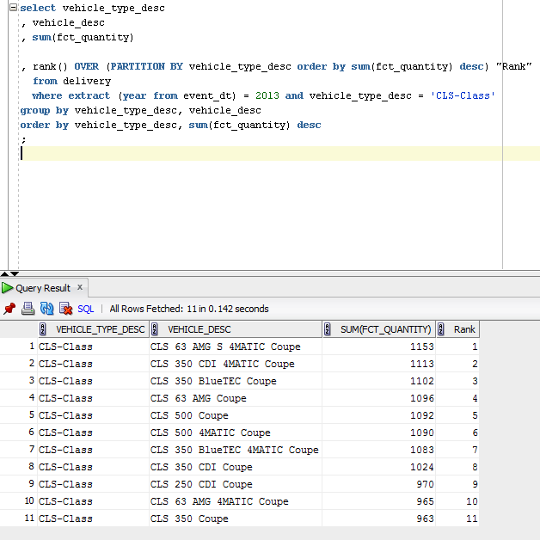

**Max**

5 deliverys with the most huge price

/* Formatted on 8/13/2013 3:10:21 PM (QP5 v5.139.911.3011) */

SELECT *

FROM ( SELECT vehicle_type_desc

, vehicle_desc

, MAX ( fct_amount )

FROM delivery

WHERE EXTRACT ( YEAR FROM event_dt ) = 2013

GROUP BY vehicle_type_desc

, vehicle_desc

ORDER BY MAX ( fct_amount ) DESC) delivery

WHERE ROWNUM <= 5;

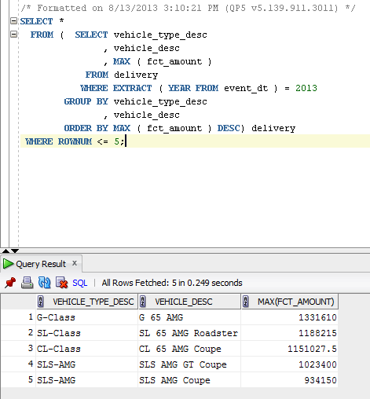

**AVG**

AVG amount of delivery by dealers.

/* Formatted on 8/13/2013 3:28:03 PM (QP5 v5.139.911.3011) */

SELECT dealer_name

, ROUND ( AVG ( fct_amount ) )

FROM delivery

WHERE EXTRACT ( YEAR FROM event_dt ) = 2012

GROUP BY dealer_name

ORDER BY 2 DESC;

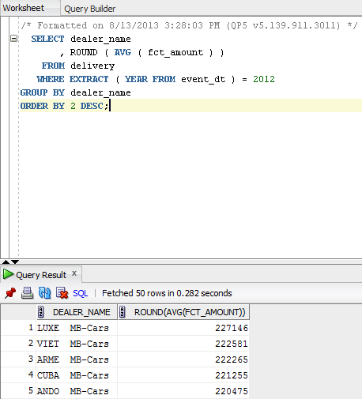

**First value and Last value**

/* Formatted on 8/13/2013 3:40:23 PM (QP5 v5.139.911.3011) */

SELECT EXTRACT ( YEAR FROM event_dt ) AS month

, vehicle_type_desc

, SUM ( fct_amount ) AS sales

, FIRST_VALUE ( SUM ( fct_amount ) )

OVER (PARTITION BY EXTRACT ( YEAR FROM event_dt ) ORDER BY SUM ( fct_amount ) DESC)

AS max_sales

, LAST_VALUE (

SUM ( fct_amount )

)

OVER ( PARTITION BY EXTRACT ( YEAR FROM event_dt )

ORDER BY SUM ( fct_amount ) DESC

ROWS BETWEEN UNBOUNDED PRECEDING AND UNBOUNDED FOLLOWING )

AS min_sales

FROM delivery

WHERE dealer_country = 'Spain'

GROUP BY EXTRACT ( YEAR FROM event_dt )

, vehicle_type_desc;

